The goal of this program was to create a food menu for breakfast, lunch, or dinner with prices depending on what letter they input that corresponds to the menu, a B for breakfast, an L for lunch, and a D for dinner. Once the user inputs which menu they would like to see the menu will be printed underneath and then prompt the user how many orders of that menu they would like. After that the program will ask the user to confirm the order with a Y for yes or N for no. If the users input is Y then the program will finish by printing the total price of order with 5% sales tax. While loops were placed inside the program to check whether the user types in B, L, or D when asked for which menu they want and for when the program asks yes or no but there’s nothing keeping the user from typing in anything other than a number.

In order to keep the program organized comments were placed above every chunk of could that involved cin, if statements, mathematical equations. A 5% sales tax was put on the prices of each menu and that price is calculated after the user confirms whether or not they want what’s on the menu. One thing that I was not satisfied with is when the user inputs an N for no on the confirmation screen the program terminates. I would have liked to use functions for this but I couldn’t remember how to use them 100% so I opted not to use them.

The program was able to be finished within a day or two. One thing that was an issue was a string value was declared and depending on which menu the user chose the name of that menu would be used throughout the rest of the program. I had forgotten to import the string library and when assigning the string a value in the if statement I had forgotten to use a single equal sign (=) instead of a double equal sign (==).

When testing the program the breakfast menu was chosen and three orders of that menu were ordered. The price of the breakfast menu is $6.99 and with the sales tax the price of order is $21.32. Since error checking was put in place when the program asks which menu you want and whether you want what you ordered the user cannot input anything other than what’s allowed. However if the user were to type in a string instead of a character and that string contained any of the allowed inputs then the program will go into an infinite loop but if the string contained characters that aren’t allowed then then program will just reject it an ask you to type another input and if the user types in anything other than an integer when asked how many orders you want off the menu then the program will go into an infinite loop there too. 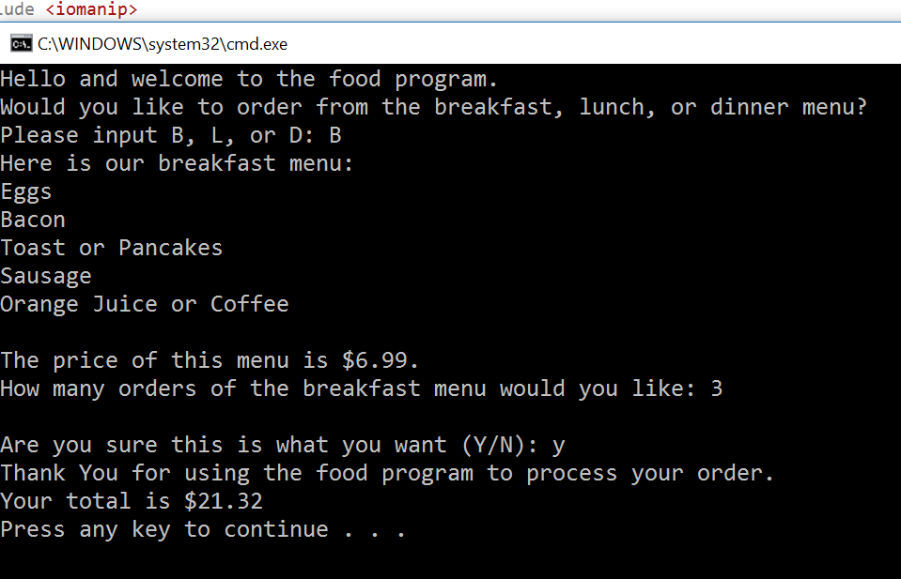

All in all, the program was a success. If I could do this differently I would like to do this with functions. The program was able to be completed in only a day or two and was not too difficult.